KIGALI INDEPENDENT UNIVERSITY ULK

PO BOX: 243 Gisenyi



SCIENCE AND TECHNOLOGY

COMPUTER SCIENCE

REPORT OF INTERNSHIP DONE

AT THE COMPANY

NOVATECH DRC/ GOMA

**From September 10th to October 10th, 2020**

Submitted by **MOZA MOENGA lynda**

An internship report submitted in partial fulfillments of academic requirement for the award of a bachelor’s degree in computer science.

Supervised by Mr. Marc MOBOKO and Mr. David Alex NTUMBA

ACADEMIC YEAR 2019 - 2020

# EPIGRAPH

One must learn by doing the thing; though you think you know it, you have no certainty until you try.

***Sophodes*.**

MOZA MOENGA lynda

# DEDICATION

MOZA MOENGA Lynda

# AKNOWLEDGEMENT

MOZA MOENGA lynda

# ACRONYMS AND ABREVIATIONS

ATM : Automated Teller Machines (En Français Guichet Automatique Bancaire)

**BSC :** Base Station Controller

CBNL : Combridge Broat Network

DNS   : Domain Name Service

FTP   : File Transfer Protocol

GPRS : General Packet Radio Service

ICMP   : Internet Control Message Protocol

IP   : Internet Protocol

LAN  : Local Area Network

MSC : Mobile Switching Centre

NTLM : Network Lan Manager

RJ45  : Registre Jack45

RTC : Reseau Telephonique Commute

SMTP  : Simple Mail Transfert Protocole

TCP/IP : Transmission Control Protocol /Internet Protocol

UDP   : User Datagramm Protocol

WAP : Wireless Application Protocol

WI-FI : Wireless Fidelity

**WIMAX :** World Wide Interoperability for Microwave Access

WLAN : Wireless Local Area Network

# ABSTRACT

Given that the government aims to educate students in ways to make them useful and beneficial to the nation, so they give a period of internship that allows students to marry the knowledge gained from the university to the professional reality. In this purpose Kigali Independent University (ULK) sent us for our practical training.

Due to this opportunity, we chose Optimum Company DRC / Goma for internships and it was one of our very good moments during our learning period.

During our training period, we had to go through the desk and where we had to learn and discover a lot of things. As computer scientists we spent most of our internship in the design department, where we had a lot of practice especially in the design of graphics and flyers and deferent kind of tools used in design.

We used the participation method and observatory method during our internship period.

# TABLE OF CONTENTS

EPIGRAPH i

DEDICATION ii

AKNOWLEDGEMENT iii

ACRONYMS AND ABREVIATIONS iv

ABSTRACT v

TABLE OF CONTENTS vi

CHAPTER 0: GENERAL INTRODUCTION 7

1.1 Internship context 7

1.2 Internship objectives 7

1.2.1 General objective 7

1.2.2 Specific objectives 7

1.3 Used methodologies 8

1.3.1 Participation 8

1.3.3. Observation 8

1.4 Internship period 8

Chapter I: History And Profile Of The Company 9

I.1.Generality 9

I.2. Vision of Vodacom 9

I.3. Commitment to Vodacom 10

I.4.Values of Vodacom Congo 10

I.5.Shareholding 10

I.5.1.Purpose 10

I.5.2.Headquarters 10

I.5.3.Charter of Excellence 11

I.6.The computer service or maintenance 12

I.6.1.Definition 12

I.6.2 Location of the Company 14

I.7. Ambition and objective of the company 14

I.8. Organigramme 14

Definition 14

Graphic presentation 15

I.8.1. Operation 1

1) The Regional Direction 1

2) The commercial service 1

3) The Operations Department 2

I.9. Encountered difficulties 2

Chapter II: Course of the internship 3

II.0. Introduction 3

II.1. Organization networks of Eastern Region office 3

II.2. Organization of tasks 4

II.3. Calenderer of the internship 12

Chapter. III: Personal Initiative of the Trainee 16

ΙΙΙ.1 Our suggestions 16

Conclusion 17

# CHAPTER 0: GENERAL INTRODUCTION

## 1.1 Internship context

During the period of internship that the government of Rwanda give to each student before being graduated the bachelor's degree with purpose of understanding what is in real life and know how he can use the knowledge got from the university to solve the people living problem in order to be benefit for the country and even for the whole world.

So, in our case, we proffered to do our internship at Vodacom DRC – Goma, for a period of a month apart from Saturdays and Sundays which started from 10th Jun to 10th July 2019.

Before closing this section let us mention that this work will contain three chapters apart from the introduction and the conclusion. The first chapter will be the presentation of Vodacom DRC – Goma, the second will be the focused on adventure of the internship and the last on the self-creativity of the internee.

## 1.2 Internship objectives

As it is known and mentioned above, the internship is the period that is organized by the education authority in order to get students able to face the real life problem and give solution to them by mixing the knowledge gained from school with the experience from the field.

The internship gives another big tool which is the learning by doing as it’s said by JOHN DEWEL. This confirms the very big importance of the internship by which students will be able to see and learn new things and transform them into actions and experience.

### 1.2.1 General objective

As it’s required to all students to pass through a practical period that all them to link the theories learned from the university to the real life realities. The main objective of the internship training is to initiate the student in the pre-professional work experience.

### 1.2.2 Specific objectives

* Develop and improve the student’s written communication skills.
* Opportunity for the student to reflect on the professional aspects of the internship experience and the skills that were learned and acquired.
* Allow the student to describe the technical content learned in the classroom.
* Help the student to reflect on the initial goals of the internship and how they were achieved or not – and the course of action that was taken.

## 1.3 Used methodologies

The methodologies used in this internship period are the participation method and the observation method.

### 1.3.1 Participation

The major part of our internship was participating, touching and performing task. That helped us to improve our technical knowledge as computer scientists.

### 1.3.3. Observation

By this method we were able to satisfy our curiosity at a big percentage by observing what the workers are doing and trying to ask question for what we don’t understand.

## 1.4 Internship period

Our internship was realized along with one month which took us from 10th June to 10th July 2019.

# Chapter I: History and Profile of the Company

## I.1.Generality

Vodacom is a South African company created by Mr. Alan Knott-Craig (Chief Executive Officer of Vodacom Group (PTY) Ltd.)

He had the vision to launch the cellular network in South Africa when he worked at Telkom Company. The Vodacom network was officially launched on June 1, 1994, but the GSM system really took off when Vodacom introduced the prepaid card system in November. Vodacom group (PTY) Ltd is a holding company consisting of the following companies:

* Vodacom (PTY) Ltd
* Vodacom Service Provider Company (PTY)
* Vodacom International Holding (PTY) Ltd

The subsidiaries of Vodacom International Holding are: Vodacom Lesotho, Vodacom DRC, Vodacom Tanzania.

Vodacom Congo is the result of a joint venture between Vodacom International Holding and CWN (Congolese Wireless Network).

Vodacom was interested in Congo because according to the analyzes, the Congo had only 100,000 phones for more than 60 million inhabitants. Vodacom wanted to invest in the Congo because it represents a significant potential market despite the prevailing economic environment. The Vodacom Congo network was officially launched on May 1, 2002 with a staff of 62 people.

Today, it has thousands of agents working with the company and various operators and has more than 10 million subscribers connected today. Based in DR Congo, South Africa, Tanzania, Mozambique and Lesotho, Vodacom will be the largest company in Africa.

## I.2. Vision of Vodacom

Vodacom’s visions are:

* Bring a smile to the lives of its customers.
* Offer the best network coverage with the best quality possible.
* Give all Congolese people access to mobile telecommunication technology to enable them to communicate and interact with different peoples around the world.
* Make the Democratic Republic of Congo a stronger nation by making its companies competitive around the world with new technologies that allow them to work efficiently.

## I.3. Commitment to Vodacom

* Protection of personal data: Implement techniques, policies and procedures that aim to protect the confidentiality, integrity of personal information.
* Respect for the law
* Fight against corruption
* Environmental Protection

## I.4.Values of Vodacom Congo

* Speed
* Simplicity
* Confidence

## I.5.Shareholding

VodaCom Congo is 51% owned by VodaCom International Limited and 49% owned by Congo Wireless Network. With a capital of 76.5 million US Dollars, its corporate purpose is to install, operate and maintain a GSM telecommunications network throughout the Democratic Republic of Congo to provide telecommunications services on a viable commercial basis.

### I.5.1.Purpose

Install, explore and maintain a GSM telecommunications network throughout the Democratic Republic of Congo to provide telecommunication services on commercially viable bases.

### I.5.2.Headquarters

The headquarters of VODACOM Congo is in KINSHASA. The whole country is subdivided into a region that may include one or more administrative provinces. It is:

* The Kinshasa region corresponding to the province of Kinshasa. Kinshasa is the seat
* Western region composed of provinces of Bas-Congo, Bandundu and Ecuador with Kinshasa as headquarters
* Southern region composed of provinces of Katanga, 2 Kassaï (eastern and western) with Lubumbashi as headquarters
* Eastern region composed of provinces of North Kivu, South Kivu, Maniema and the Eastern Province of which Goma is the seat.

### I.5.3.Charter of Excellence

Vodacom is a victorious society, where everyone has a clear will and a passion in everything they do to be better, to never give up, to work more than all the others, to know that the best Vodacom is better than the best of all the others. There is no question of losing. Vodacom is a team and the competition and its sport.

Communication and Information. And manages one of the customer sectors of the modernization of the country as evidenced by some services offered by the latter.

* The Mobile Data Service (GPRS / EDGE) is a technology that allows a phone to transfer data (images, sounds, text) at faster speeds and more efficiently than on the GSM data network;
* VODA-E is a means of electronic recharge under prepaid cards of VODACOM subscribers in prepayment mode
* VODACOM Infotext: activation of Fax and Data Services by SMS. This service enables VODACOM subscribers to activate Fax over phone services with a simple SMS.
* VODACOM Crédinet: CREDINET is a flexible and flexible way in which a company can directly allocate communication credits to its subscribing agents.
* VODACOM SMS: The SMS is a service that allows us to send a written message of up to 160 characters
* VODACOM-E-mail to SMS: This service allows Vodacom subscribers to receive and read via SMS on their mobile phones e-mails sent directly to e-mails.
* VODANET: this service allows all subscribers to benefit from the internet connection either on the telephone or at home via transmission devices.
* The company VODACOM hosts several services that it offers to its customers. For more information consult the website of the company: [www.vodacom.cd](http://www.vodacom.cd).

## I.6.The computer service or maintenance

### I.6.1.Definition

The computer or maintenance department is a support service of Vodacom, which is in charge of controlling and troubleshooting vodalan's IT tools, as well as managing all the agents in Lan vodacom and all the applications that work well thanks to the IT service used by them.

The Lan VodaCom is a star Lan because everyone connects to the Switch that is in the IT office.

The service desk accesses its resources as follows:

* The connection of the vodalan takes its source from the machines of the workers who are in the Lan network,
* From the patch panel to the Switch. From this switch comes a cable that goes to the DAC port of the stratex, this port helps us out through the MACRO WAVE to the other MACRO WAVE to KATOYI. There is also a stratex that has a DAC port on which there is a cable that allows us to go to the MSC. And this is where the two servers are.
* Exchange server: who handles Outlook mail
* The controller domain: which is responsible for identifying users in the LAN VODACOM domain
* From the MSC we return to KATOYI and KATOYI we go directly to KINSHASA;
* In the service desk we use an application called ICAP.

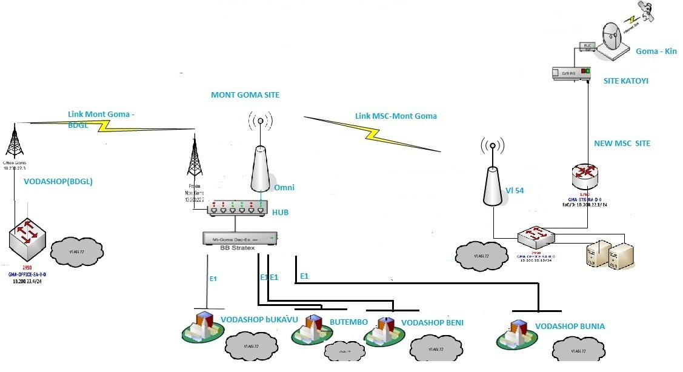

### I.6.2 Location of the Company

The Eastern region includes North Kivu, South Kivu and Maniema. Its headquarters are in Goma on KANYAMUHANGA Boulevard in the former Kivu Market Building.

## I.7. Ambition and objective of the company

The slogan "VodaCom, leader in the cellular world" is not a vain word but a state of mind that every day asserts itself on the ground by concrete actions. Since its introduction, this slogan has led to significant changes in the Congolese mobile cellular market. By the seriousness of its investment and know-how, VodaCom Congo has demonstrated that it is indeed a society whose leadership has transformed the experience of Congolese access to telecommunications in the most inaccessible corners of the Congo. DRC. Being the number one telecommunications company in the DRC remained VodaCom's first ambition.

For VodaCom, the phone should not be the privilege of the few privileged inhabitants of certain particular cities. All Congolese are equal and should be entitled to the same treatment, access to the same services and at uniform prices or across the country.

## I.8. Organigramme

### Definition

The organization chart is a descriptive schema that determines and sets the attributions, hierarchical and functional links within an organization.

### Graphic presentation

### 

In the Eastern Region's administrative organization, there are three main services:

* Commercial services (Marketing, Public Phone, AccountExecutuve, Shop, Warehouse ...)
* Finances, and
* Operations subdivided into sub-departments.

## I.8.1. Operation

### The Regional Direction

At the head of the Eastern region, we find the Head Officer or Head of Region: he coordinates all activities and operators; he is in liaison staff with the secretary and in charge of personnel (Personnel Assistant and Secretary).

### The commercial service

Its mission is to manage the supply and sale of VODACOM products from KINSHASA and to enable salespeople in sales outlets to make their business profitable. He has it:

* The Commercial Manager: he oversees the service.
* Marketing Rollout Supervision: it coordinates all the actions aimed at knowing, anticipating and, possibly, stimulating consumers' needs with regard to goods and services and adapting the productive and commercial with specific needs; regional media coverage comes back to him.
* The Brand and Distribution Executive / Field Marketing: his job is to see the sales situation on the field, so he takes care of the field.
* The Public Phone Supervisor: it deals with the sector of public booths, electronic devices, printing of prepaid cards (EVD available at all dealers and resellers, and Fax and Voda-E services).
* VODA SHOP Offices in Goma, Bukavu and Butembo: which coordinate Negotiation activities in these cities.
* POSTPAID Manager and AccountExecutive: selects orders and deliver VODACOM products to Superdealers and handles Post Paid connections.

### The Operations Department

He is responsible for the management of the technical sector in the East region. At its head is the Line Manager. He is assisted by pool heads and they are assisted by technicalofficers. The Eastern Region is subdivided into six pools (Goma, Bukavu, Uvira, Kindu, Beni and Butembo).

* The Account is responsible for carrying out the payment transactions of the amounts ordered by the various departments and keeps the accounts of the company;

The Warehouse Officer deals with the management of the store (depot) containing all the technical and marketing materials; the latter is responsible for receiving them and dispatchers in all the other cities / cities in need according to the directives of the services concerned throughout the Eastern region.

## I.9. Encountered difficulties

In the service desk or computer, we encountered as difficulties:

* The computer room does not have emergency exits to evacuate staff in the event of a disaster.
* Many of the agents do not have basic knowledge of the computer tool and that is a burden on the IT to intervene every time in case of small problems that would not even require the intervention his intervention.

# Chapter II: Course of the internship

## II.0. Introduction

In this part, we will report in a non-exhaustive and clear way the activities carried out during our internship in the 2 services: the I.T service and the Vodanet service.

During the internship we had to participate in different activities in the IT department of vodacom / Goma where we not only had explanations about the different equipment, but also we could feel the technical reality.

We could also participate in the reinstallation of the CBNL and VL equipment which is the main operation of the Vodanet service for our how it works.

## II.1. Organization networks of Eastern Region office

The office is connected from 2 connections to 2 antennas: a CBNL antenna and a MICROWAVE antenna; these 2 antennas are subdivided into VLANs which lead on one side the LAN-VODACOM and the other VLAN drives the internet. In the rack is a switch connected to the patch panel; from this switch comes the RJ45 jacks for each office.

Finally, this switch is connected a router located in the main room that allows access to LAN-VODACOM via WI-FI.

Agents must have permanent access to the Microsoft Exchange mail server located at the Goma MSC on behalf of Eastern region before they can read and send their mail through the Outlook application.

Agents must also have access to the ICAP application server located in Kinshasa; indeed, ICAP is the application that allows you to manage Vodacom subscribers: via the registration, the m-Pesa, the Swapp service, ...

Printers are connected to LAN-Vodacom; so, they are available to all agents connected to LAN-Vodacom

## II.2. Organization of tasks

During the internship, we had different tasks to do, including:

* How to archive the email belonging to the Outlook but which are connected to the ICAP server, which will allow the users to receive and send the email.
* Operating system installation: At Vodacom, the parameters to consider when installing a desktop computer are: the system version (Enterprise), the system language (English), the name Administrator User (User) and also the Computer Name according to the following Syntax: PC-NB (Notebook) or D (Desktop) or OS - Vodacom label number. This is to allow standard identification when adding the computer to the Vodacom.cd domain.
* Adding a computer to the vodacom.cd domain.

1. Go to PC, right click then property

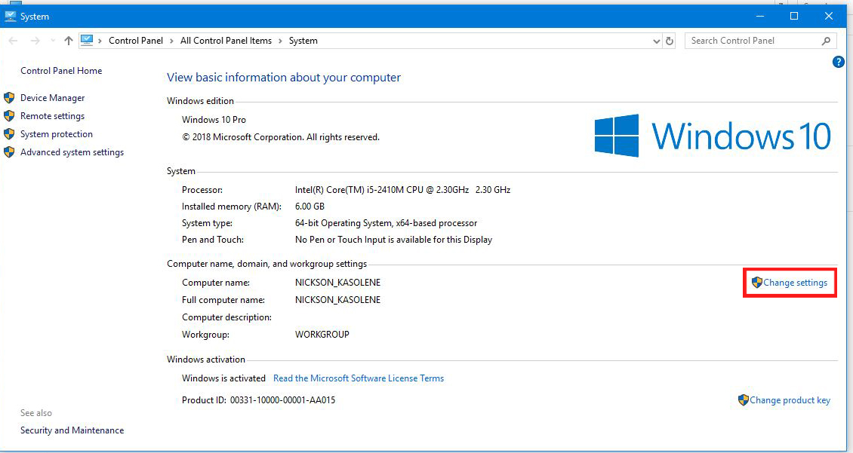

2. Change the settings

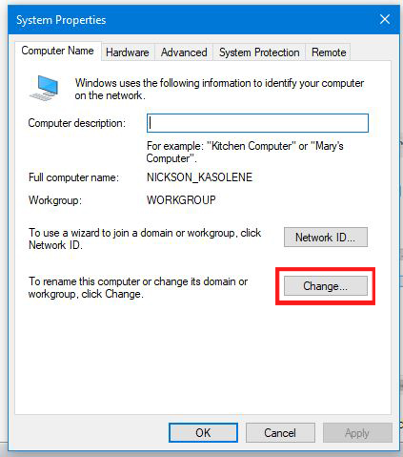

3. Edit and to the option Member of a: choose domain and type vodacom.cd which is the domain name of vodacom

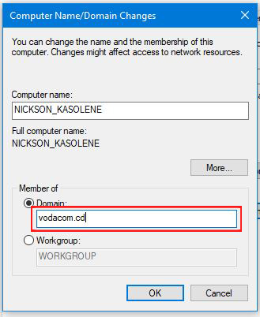

* Verification of the internet connection: this is done every morning to make sure that the agents can access the various Vodacom LAN applications that are erected into the vodacom.cd domain. In short, the INTRANET Vodacom; verification is also done in the event of an agent complaint and pinging the ICAP server using the PING command in MS.

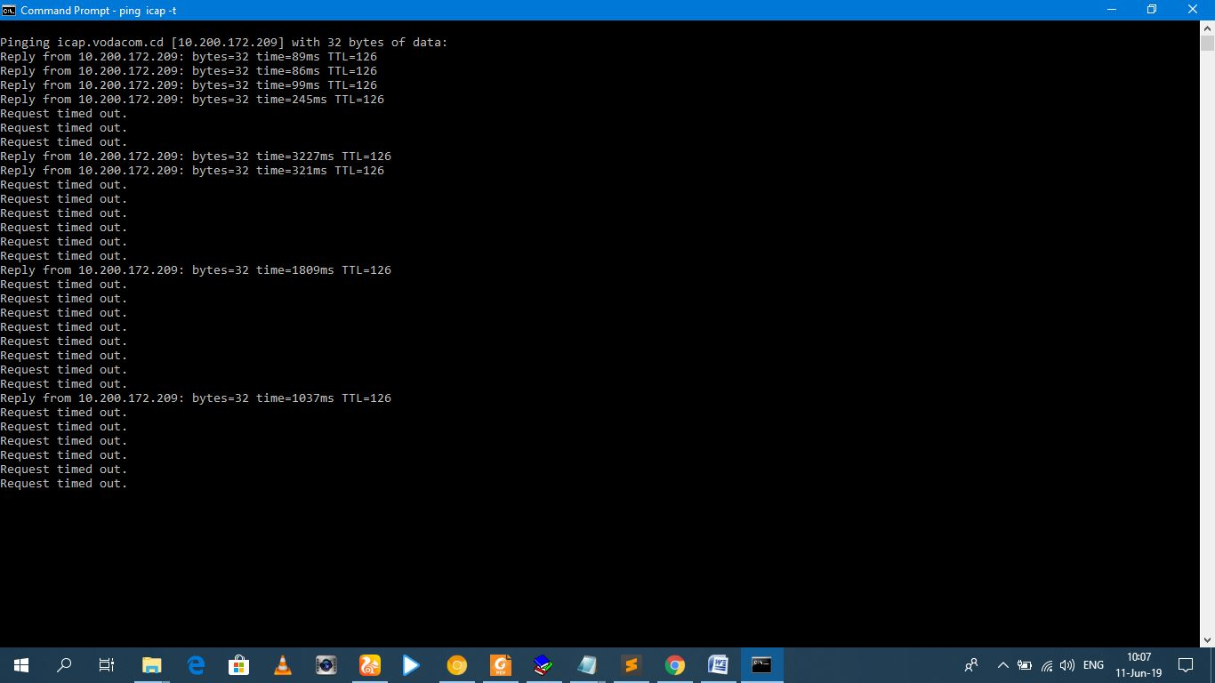

* Installation and configuration of Vodanet services at customers

In the Vodacom Network the WAN addresses at the customers are entered manually by the technician in order to avoid address conflicts in the network.

Vodanet mainly provides 2 services: data and internet

For the internet the customer has 3 possibilities:

- Either he buys a NETBOX: it is an Access Point having another for a VODACOM virtual sim card and which provides the internet as a phone but with a large capacity.

- Or it is installed an antenna ALVARION, which should therefore have an orientation to one of the Vodacom BSC nearest, that is to say without obstacle with the antenna.

- Either a CBNL antenna is installed, the CBNL antenna is an antenna with a high throughput capacity, however due to the exorbitant cost, Vodacom installs these antennas at customers with a large data flow.

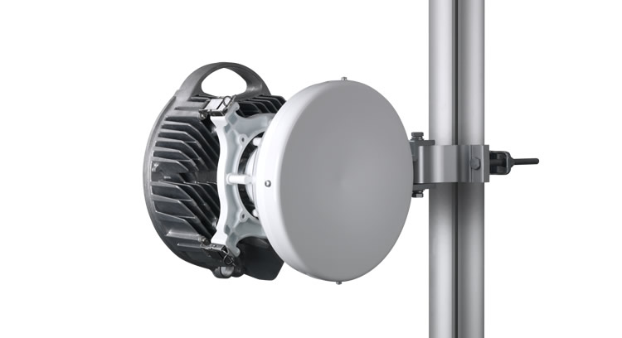

It should be noted that Vodacom takes its internet from a provider called SKYNET.

For the data service:

This is a special service that vodacom offers to certain companies; this service is such that Vodacom, thanks to its local network support (INTRANET), connects the different representations of the company all over the DRC to the server that owns the application of the company.

This is the service that Vodacom delivers to the DGDA with their SYDONIA application and RAWBANK.

The Vodanet data service for SYDONIA is configured such that the main router of East Zone (Goma) has for address IP: 10.80.23.1 and thus during the configurations it is this router which closes of gateway by default to transit towards Kinshasa to the server of SYDONIA.

* Troubleshooting Networks at a customer

Indeed, the Vodanet Service ensures that the customer is satisfied with the internet connection provided, where in case of failure the customer informs the administration and the administration sends field technicians; to troubleshoot the network we proceeded by connectivity tests to the BSC configure for the site by ping and we check the flow rates of the incoming and outgoing packets through Telnet.

From this result, the failure is detected; it may happen that either maintenance work can simply rotate the antenna (VL or CBNL) and reconfigure the IP addressing parameters of the router and the antenna; either the antenna has been struck by lightning, in this case the antenna is changed.

* Configuring a router and access point

There are 2 types of access to the router and access point:

- There is console access: it is RJ45 network cable access

- There is remote access: this happens such as once the router allowing remote access or the access point turned on; we connect to the SSID of his network; then according to the indications coming with the equipment; in the browser of our computer; type the IP address of the router as indicated by the equipment; this allows us to switch to the configuration GUI after authenticating.

The configuration has 2 important parts:

- The configuration of the WAN: it is the configuration of the way the router accesses the Internet (or LAN-VODACOM).

- The configuration of the LAN: it is the configuration of the hosts of the router to the access point. In short; here it is a question of giving a significant SSID, a password, an IP address to the local network of the router, there is also the way of administration of IP address to the hosts of the local network of the router; for the Vodacom desktop router we disabled address assignment by the DHCP server of the router in order to avoid address conflicts in the LAN-VODACOM.

There is also the administration configuration which allows to change the access password to the router.

* Setting up an Outlook account

Vodacom uses Outlook as the messaging tool; thus, Vodacom has established a system such as in the LAN-VODACOM network, there is a mail server and each agent must have an email account to receive different notifications about the service in which he works.

The configuration of Outlook requires the knowledge of the IP address of the server of the mails and also it will be necessary that the account exists and is active.

The option Manual setup or additional server types is selected for a computer that has already been placed in the LAN-VODACOM to allow an automatic configuration because each user account on the LAN-VODACOM corresponds to an Outlook account as well as the IP address of the server mails is directly identified for the computer that is in the mail So as soon as the user information will be entered it will be necessary; tap next and then set the mail server settings.

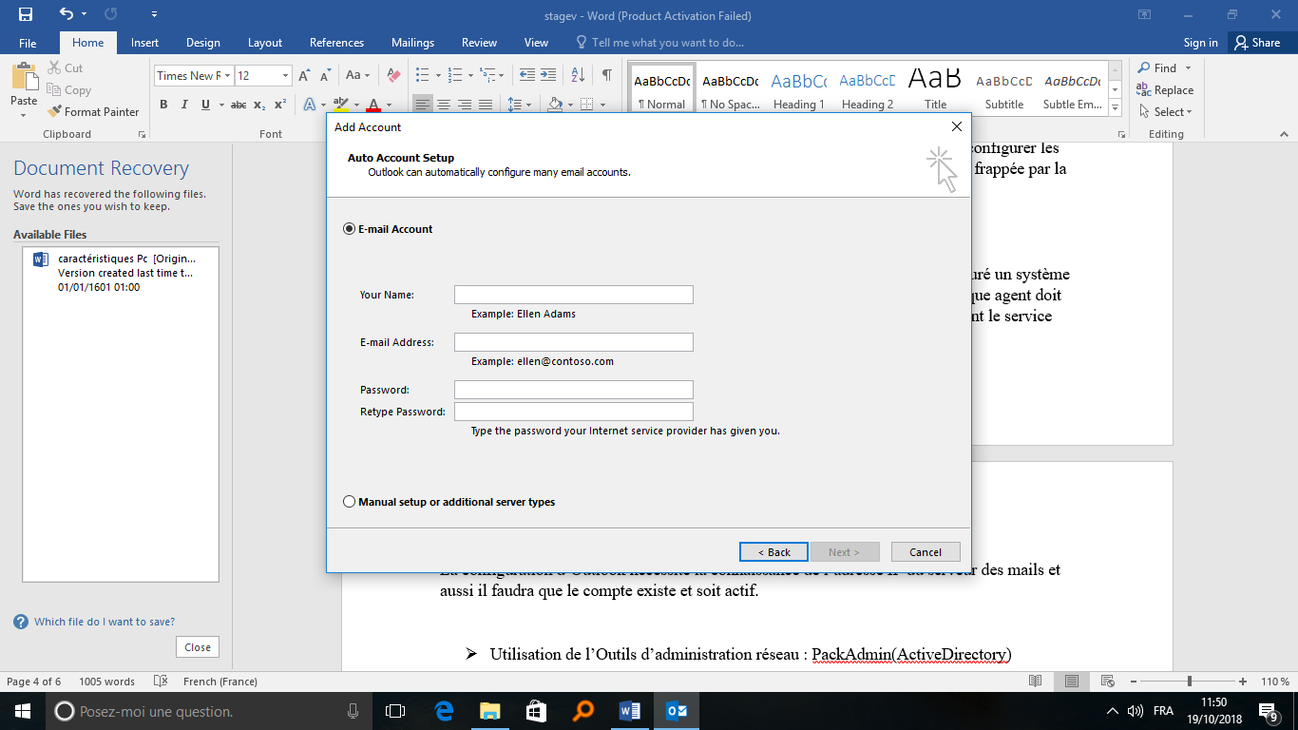

* The G-Drive

The G-Drive is a hard drive located on the network that allows to keep files in a safe way and having the possibility to access them at any place if one is in the LAN-Vodacom.

To access it to this hard drive share; we go into the file explorer and then right click on networks and we chose to connect to a network drive.

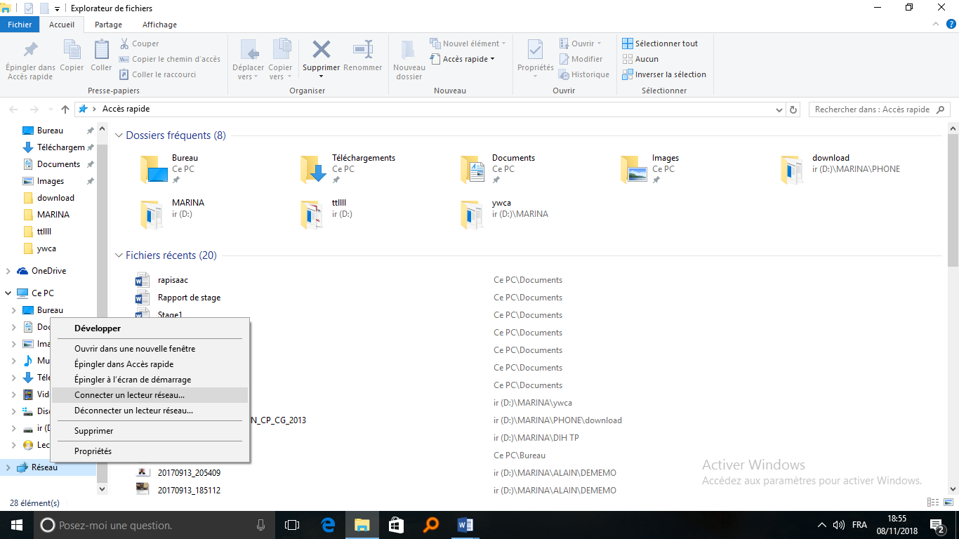

From there, just place the address of the shared drive or G-drive and click finish.

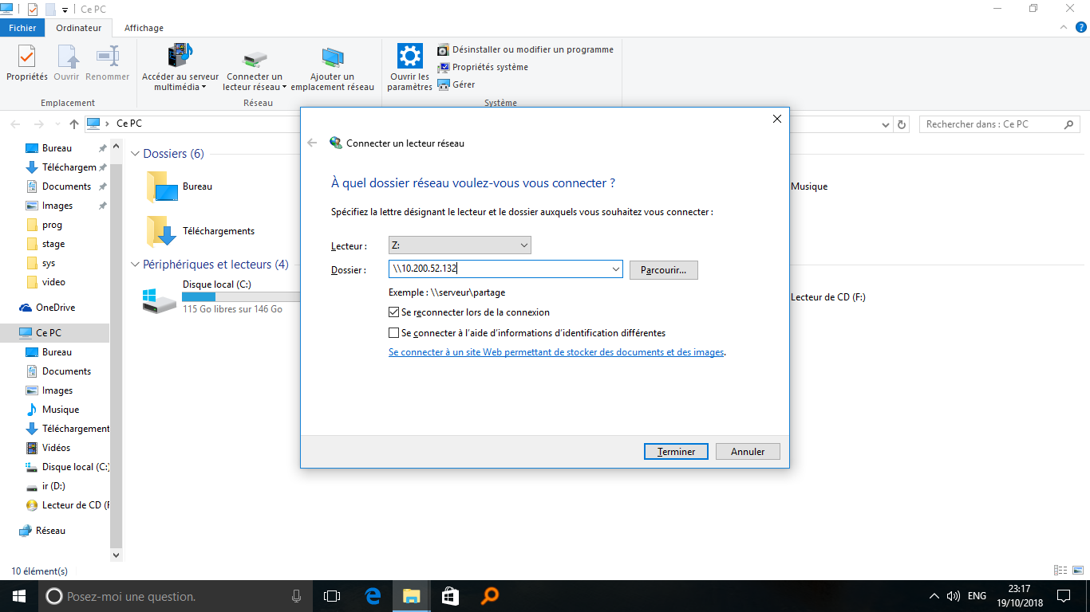

* Technical control of equipment

It is a question of making an equipment test in order to classify them before returning this equipment to the WareHouse hand.

There are 2 codes for specified equipment status: Faulty for bad equipment and Good for equipment in good condition.

Each Vodacom equipment carries a label that uniquely lists the equipment to effectively manage equipment at the Warehouse.

* Installing a network printer

The printer must be connected in the LAN; to install a printer, first the computer must be connected to the LAN-VODACOM, then in the control panel click on add a device, from there opens a page that lists all the devices connected to the network; just choose the printer you would like to add to this list.

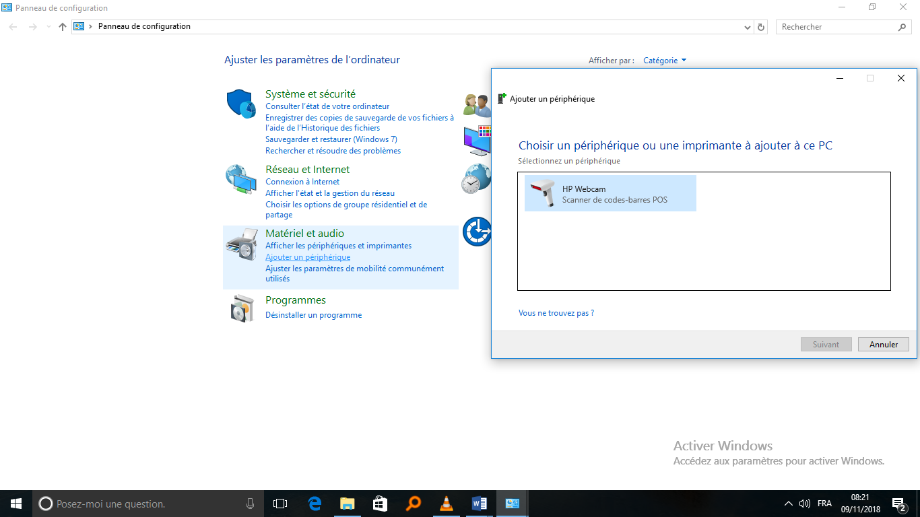If the printer requires installation and the installation is stored in the printer's memory, we should connect to the printer network via the browser by typing the IP address of the printer on the network in the printer. Address bar of the browser then we download the printer installation software and install it and finally we do as before.

* REMEDY IT MANAGEMENT application

This application allows the tracking of Vodacom IT agents; whenever there is a problem; in the application, the person who posed the problem and the time of the report should be noted; the engineer who solved the problem and the end time of solving the problem.

* Using the Network Administration Tools: PackAdmin (Active Directory)

Vodacom has its network configure under Windows and the network administration tool allows to manage the various accounts of Vodacom agents and offers the possibility of being able to reset an agent password, to block a user account of an agent, block online printing for a printer, and many other important features for managing network users.

This tool also allows updates, activation by Windows licenses and uniformity of screen sleep the computers of the domain Vodacom.cd.

It should be noted that this tool can only be used on an Administrator account.

## II.3. Calenderer of the internship

|  |  |
| --- | --- |
| Days and Date | Accomplished tasks |
| WEEK 1 | | |
| Monday, June 10, 2019 | * Handshake, presentation of Vodacom DRC company; * Presentation and explanations of tools used. |
| Tuesday, June 11, 2019 | * Connect the computer in the vodanet.cd domain; * Solve the print issue of the agent. |
| Wednesday, June 12, 2019 | * Verification of the LAN network; * CBNL, PACTH PANEL ETS WITCH How it works and how to do it if it does not work; |
| Thursday, June 13, 2019 | * Verification of the power supplier; * Troubleshooting in Vodacom. Shop (installing the printer and print remotely) |
| Friday, June 14, 2019 | * Verification of the LAN network; * Verification of the power supplier; * Explanation on the usage of the tool Outlookat VODACOM. |
| WEEK 2 | | |
| Monday, June 17, 2019 | * Verification of the LAN network; * Installation of Microsoft Office in the computer of an Agent. |
| Tuesday, June 18, 2019 | * Verification of the LAN network; * Verification of the power supplier; * Explanation about configuring a router |
| Tuesday June 19, 2019 | * Verification of the LAN network; * Verification of the power supplier; * Configuring Outlook Mail and How to Archive It in a User's Mailbox |
| Thursday, June 20, 2019 | * Verification of the LAN network; * Verification of the power supplier; * Installation and configuration of the CBNL and PATCH PANEL of the new in the Shop. |
| Friday, June 21, 2019 | * Verification of the LAN network; * Verification of the power supplier; * Installation of Drivers. |
| WEEK 3 | | |
| Monday, June 24, 2019 | * Verification of the LAN network; * Verification of the power supplier; * Repairing the connection in the internal network of the office |
| Tuesday, June 25, 2019 | * Verification of the LAN network; * Verification of the power supplier; * Installing MS Office on an agent's computer |
| Wednesday, June 26, 2019 | * Verification of the LAN network; * Verification of the power supplier; * Troubleshooting Network within the company OCC |
| Thursday, June 27, 2019 | * Verification of the LAN network; * Remote machine configuration belonging to SKYPE BUSSINESS. |
| Friday, June 28, 2019 | * Verification of the power supplier; * Explanation of antenna tools that vodacom use for 4G. |
| WEEK 4 | | |
| Monday, July 1, 2019 | * Verification of the LAN network; * Repairing the connection in the internal network of the office; * Technical assistance at the East Region Vodacom office; |
| Tuesday, July 2, 2019 | * Verification of the power supplier; * Configuring the router; * Repairing the connection in the internal network of the office. |
| Wednesday, July 3, 2019 | * Verification of the LAN network; * Verification of the power supplier; * Changing the cartridge of a computer. |
| Thursday, July 4, 2019 | * Verification of the LAN network; * Mails File Restore from a Manager; * Explanation of the service REMEDY IT MANAGEMENT. |
| Friday, July 5, 2019 | * Verification of the LAN network; * Verification of the power supplier; * Downloading and installing drivers on an agent's computer; * Solve the communication issue of the Skype Business of an Agent. |
| WEEK 5 | | |
| Monday, July 8, 2019 | * Connect agents' machines to the LAN; * Repairing the connection in the internal network of the office and configuration of VoIP in different office; | |
| Tuesday, July 9, 2019 | * Repairing a Central Unit and Archiving Agent Mail; * Remote machine configuration belonging to SKYPE BUSSINESS | |
| Wednesday, July 10, 2019 | * Verification of the LAN network; * Verification of the power supplier; * Network installation and configuration of a printer. | |
| Thursday, July 12, 2019 | * Configuring a CISCO LinksysWAP610n APN; Adding a computer to the domain and configuring Outlook e-mail; * Troubleshooting in Vodacom. Shop installation of network and configuration of Router | |
| Friday, July 12, 2019 | * Installing drivers on an agent's computer; * How to Archive It in a User's Mailbox of agent. | |

# Chapter. III: Personal Initiative of the Trainee

At this stage, we have been integrated in the professional sphere and our adaptability was quickly made because, the theory learned from classes allowed us to make into practice our knowledge.

We want to support Vodacom DRC - Goma for its trainee management even if it is a part of its mission. We encourage much more the working mood that VODACOM authorities have established within its. We also encourage the IT manager for the sacrifices provided for our favor.

To the future students we suggest them to complete their internship at this company for them to get also the advantage of being well trained.

## ΙΙΙ.1 Our suggestions

We suggest to VODACOM the following:

* May the company balances the internship calendar ;
* May the company equip the student with the working tools such helmet, waistcoat for engineers, and gloves, in case of vodanet service;
* May the company consider the internship report written in English for the students from the Anglophone universities;
* May the company encourage students by insuring their transport.

We suggest to the Kigali Independent University the following:

* May the University organizes the internship of at least one month each year, for students to have more time to marry their knowledge acquired from classes to the practice;
* May the University strengthen the supervisions during the internship period.

# Conclusion

Being at the end of our internship at the company VODACOM, we are in an attitude of joy and satisfaction of what we learned from the internship. This one has really opened us to the professional world and now, we have a proven knowledge of the functioning, the structural organization and the attributions in the computer support service within VODACOM.

During this professional experience, we discovered the behavior of the professional career and benefited from an ambient working environment which allowed us to become familiar with and adapted to the work performed in these services of VODACOM.

For this reason, we salute the respect of the unity of command shown by the different services and the attitude of humility that characterizes its training operations. May we congratulate all the heads of services for their regularity and diligence.

We salute the company VODACOM via its manager for contributing to our professional training and hope that our suggestions and recommendations will be taken into consideration.